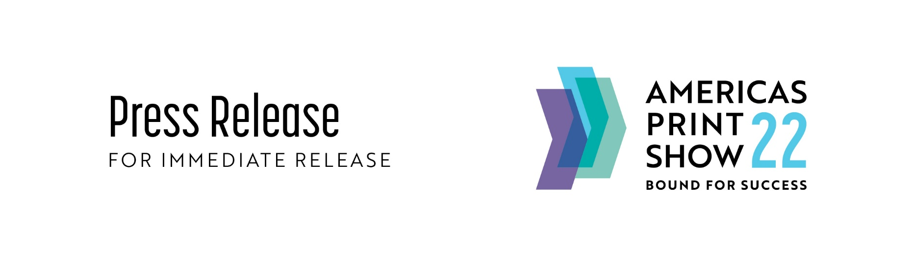

FOR IMMEDIATE RELEASE

Americas Print Show, APS22 welcomes award winning printers from across the country

June 30, 2022 (Columbus, Ohio)

Top printers from California to Minnesota, the Carolinas to New England, and the host state of Ohio are making plans to attend APS22 and celebrate their success in the inaugural 2022 Americas Print Awards, a national competition that recognizes the absolute finest in printing across the United States.

Eleven participating associations of APAN (Americas Printing Association Network) sent their top 15 winning entries of their individual competitions to the Printing Industries of New England (PINE). A panel then judged these national winners on June 13-14.

The associations include: Graphic Arts Association (GAA), Graphic Media Alliance (GMA), Printing & Graphics Association MidAtlantic (PGAMA), Printing & Imaging Association of Georgia (PIAG), Printing & Imaging Association of MidAmerica (PIA MidAmerica), Printing Industries of New England (PINE), Printing Industries of Southern California (PIASC), Printing Industry Association of the South, Inc. (PIAS), Printing Industry Midwest (PIM), Printing Industry of the Carolinas (PICA), and Visual Media Alliance (VMA).

Their “best of the best” pieces went head-to-head in this national competition. The work was judged by three leading print industry experts with over 90 years of cumulative experience. The judges were chosen from a pool of like individuals that have either owned, operated or managed a printing facility.

The winning pieces will be on display at Americas Print Show 22 in Columbus, Ohio, August 17-19, 2022.

Kacy Perkins, Marketing Project Manager with MCC Label shared her excitement. ““We are thrilled to be helping our customers produce so many amazing labels, like the True Myth label, and receiving recognition from organizations such as Americas Printing Association Network -APAN is so gratifying. It’s always such a tremendous honor to win, knowing we have showcased our customer’s product in the best light and recognizing the hard work our team puts into each label every day. We are very excited to be attending Americas Print Show and to be able to accept the award for our best work and learn from our industry peers.”

Winning printers will receive their awards and the recognition of their peers at APS22’s Welcome Reception. The event is being hosted by Graphic Media Alliance and Americas Printing Association Network on opening night of the show, Wednesday, August 17th. The reception is open to all APS22 attendees and will be an incredible conclusion to the show’s first day of educational presentations, exhibitions, and networking opportunities.

APS22 President Jim Cunningham believes, “One of the strengths of APS22 is our connection to the print community through the participation of more than two dozen associations and their members, like these award-winning printers. APS is being built to be the best, and we welcome the best in print from our industry. PS22 is getting stronger the closer we get to August 17th and we look forward to connecting with everyone at our first-year event.”
_____________________________________________________________________________

FOR EXHIBITORS
To join our quickly growing, power-packed line-up, exhibitors can reserve a premier booth location today at a substantially reduced rate compared to other industry shows.

An interactive map makes it easy to review current availability and book your space online in real-time. The exhibitor-friendly Columbus Convention Center is one of the busiest expo centers in North America.

FOR ATTENDEES
Attendance is completely FREE to the show, to participate in the educational sessions and more throughout our three-day event. Stipends are available for high school and college age students. Register in advance online.

AMERICAS PRINT SHOW
Greater Columbus Convention Center
400 N. High St. Columbus, Ohio 43215
August 17-19, 2022

www.americasprintshow.com
____________________________________________________________________________
For additional information, please contact:  Americas Print Show  showinfo@americasprintshow.com  614-306-0270 | Follow us on:  FACEBOOK AmericasPrintShow  LINKEDIN Americas Print Show  TWITTER @AmericasPrint  INSTAGRAM @americasprintshow

